**THE ROOTS OF QUADRATIC EQUATION**

**Analyze the problem: (3 points):** Write an algorithm for the program  
and present it on the flowchart diagram.

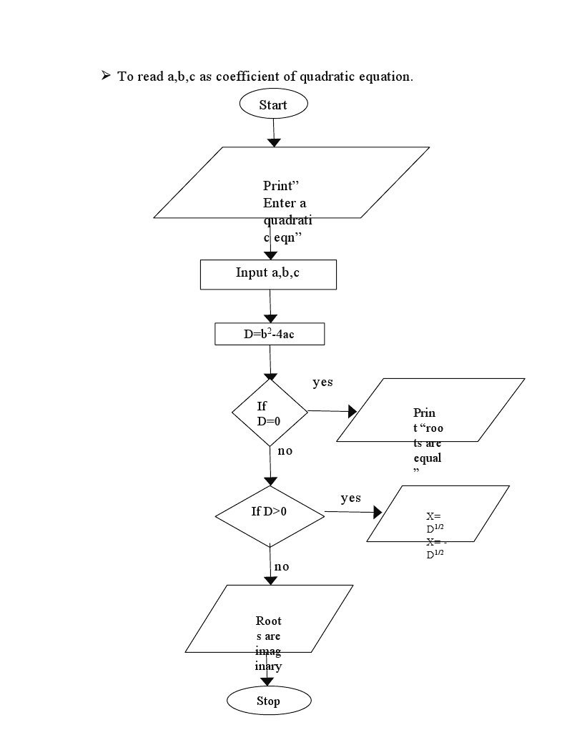

2.) **Implementation: (5 points)** Write a program in C# in Visual Studio

using System;

using System.Collections.Generic;

using System.Linq;

using System.Text;

using System.Threading.Tasks;

namespace QuadraticEquationConsole

{

    class QuadraticEquationHelper

    {

        public static int calculateDiscriminant(int a, int b, int c)

        {

            int discriminant = b * b - 4 * a * c;

            return discriminant;

        }

        public static double calculateX1(int a, int b, int discriminant)

        {

            return (-b + Math.Sqrt(discriminant)) / 2 * a;

        }

        public static double calculateX2(int a, int b, int discriminant)

        {

            return (-b - Math.Sqrt(discriminant)) / 2 * a;

        }

    }

    class Program

    {

        static void Main(string[] args)

        {

            int a, b, c;

            Console.WriteLine("Enter a:");

            a = Int32.Parse(Console.ReadLine());

            Console.WriteLine("Enter b:");

            b = Int32.Parse(Console.ReadLine());

            Console.WriteLine("Enter c:");

            c = Int32.Parse(Console.ReadLine());

            int discriminant = QuadraticEquationHelper.calculateDiscriminant(a, b, c);

            Console.WriteLine("Discriminant= "+ discriminant);

            double x1 = QuadraticEquationHelper.calculateX1(a, b, discriminant);

            double x2 = QuadraticEquationHelper.calculateX2(a, b, discriminant);

            Console.WriteLine("X1 = "+ x1);

            Console.WriteLine("X2 = "+ x2);

            Console.WriteLine("Press any key to continue...");

            Console.ReadKey();

        }

    }

}

3.) **Testing and post analyze: (2 points):** Chose at least ten (10) test  
cases which will efficiently test the program from 2. Present the tests in the  
following table:

|  |  |  |  |  |  |
| --- | --- | --- | --- | --- | --- |
| Test case | a | b | c | Results (x1, x2) | Discriminant |
| 1 | 2 | 3 | 4 | NaN, NaN | 23 |
| 2 | 1 | 2 | 3 | NaN, NaN | -8 |
| 3 | 5 | 4 | 2 | NaN, NaN | -24 |
| 4 | 8 | 9 | 5 | NaN, NaN | -79 |
| 5 | 6 | 8 | 3 | NaN, NaN | -8 |
| 6 | 3 | 6 | 9 | NaN, NaN | -72 |
| 7 | 9 | 6 | 3 | NaN, NaN | -72 |
| 8 | 2 | 4 | 8 | NaN, NaN | -48 |
| 9 | 8 | 2 | 4 | NaN, NaN | -124 |
| 10 | 12 | 24 | 32 | NaN, NaN | -960 |